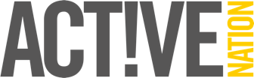
PHOTOGRAPHY & VIDEO CONSENT FORM

We would be grateful if you would fill in this form to give us permission to take photos / videos of you (or your child if applicable) and use these in our printed and digital publicity.
Active Nation will take all reasonable steps to ensure all photos and videos taken are used solely for the purposes they are intended. If you become aware that these images are being used inappropriately you should inform communities@activenation.org.uk immediately.

If a child under 16 is being filmed, consent must be obtained from parents / guardians.
I give consent for my photography to be used: (please tick)
- within Active Nation venues for display purposes
- on printed publications such as flyers, posters and other printed adverts
- on websites owned by Active Nation
- on social media pages owned by Active Nation

I give consent for video footage of me to be used: (please tick)
- within Active Nation venues for display purposes
- on websites owned by Active Nation
- on social media pages owned by Active Nation

Signature:
Print name:
Child’s name (if applicable):
Date:

