
 The Quays Swimming and Diving Complex
persuading the nation to be Active 27 Harbour Parade
Southampton SO15 1BA
www.activenation.org.uk Diving Office: 023 8072 0922
Reception: 023 8072 0900

Dear Diving Enthusiast

Olympic Family Springboard/Highboard Diving at the Quays:

Thank you for your interest in Olympic family diving at the Quays. Our sessions cater for family groups of up to 4 participants aged 6+ years. At least one member of the party must be adult. All participants must be able to swim at least 25m unaided, be confident in deep water and happy to swim without goggles.

Participants will have instruction from Olympic silver medallist Peter Waterfield and will work in a group of up to 8 divers. Peter will organise the session based on the capability of those taking part. Sessions last for 30 mins.

If you are interested in taking up the opportunity of learning with us, please fill in the booking form
and return with your payment to the Quays. You may also book on the phone. Please ensure that you
make your booking at least 48h before the lesson. Payment must be made with all bookings before they
can be entered on the system and a place reserved.

We look forward to welcoming you to the programme.
Yours sincerely

Anne Clewlow
Diving Programme Manager
023 8072 0922 / divingatthequays@activenation.org.uk

OLYMPIC MASTERCLASSES: FAMILY (30 min)
Day | Date | Time |  |  | Day | Date | Time
Mon | 08/08/16 | 18:15 |  |  | Fri | 19/08/16 | 18:15

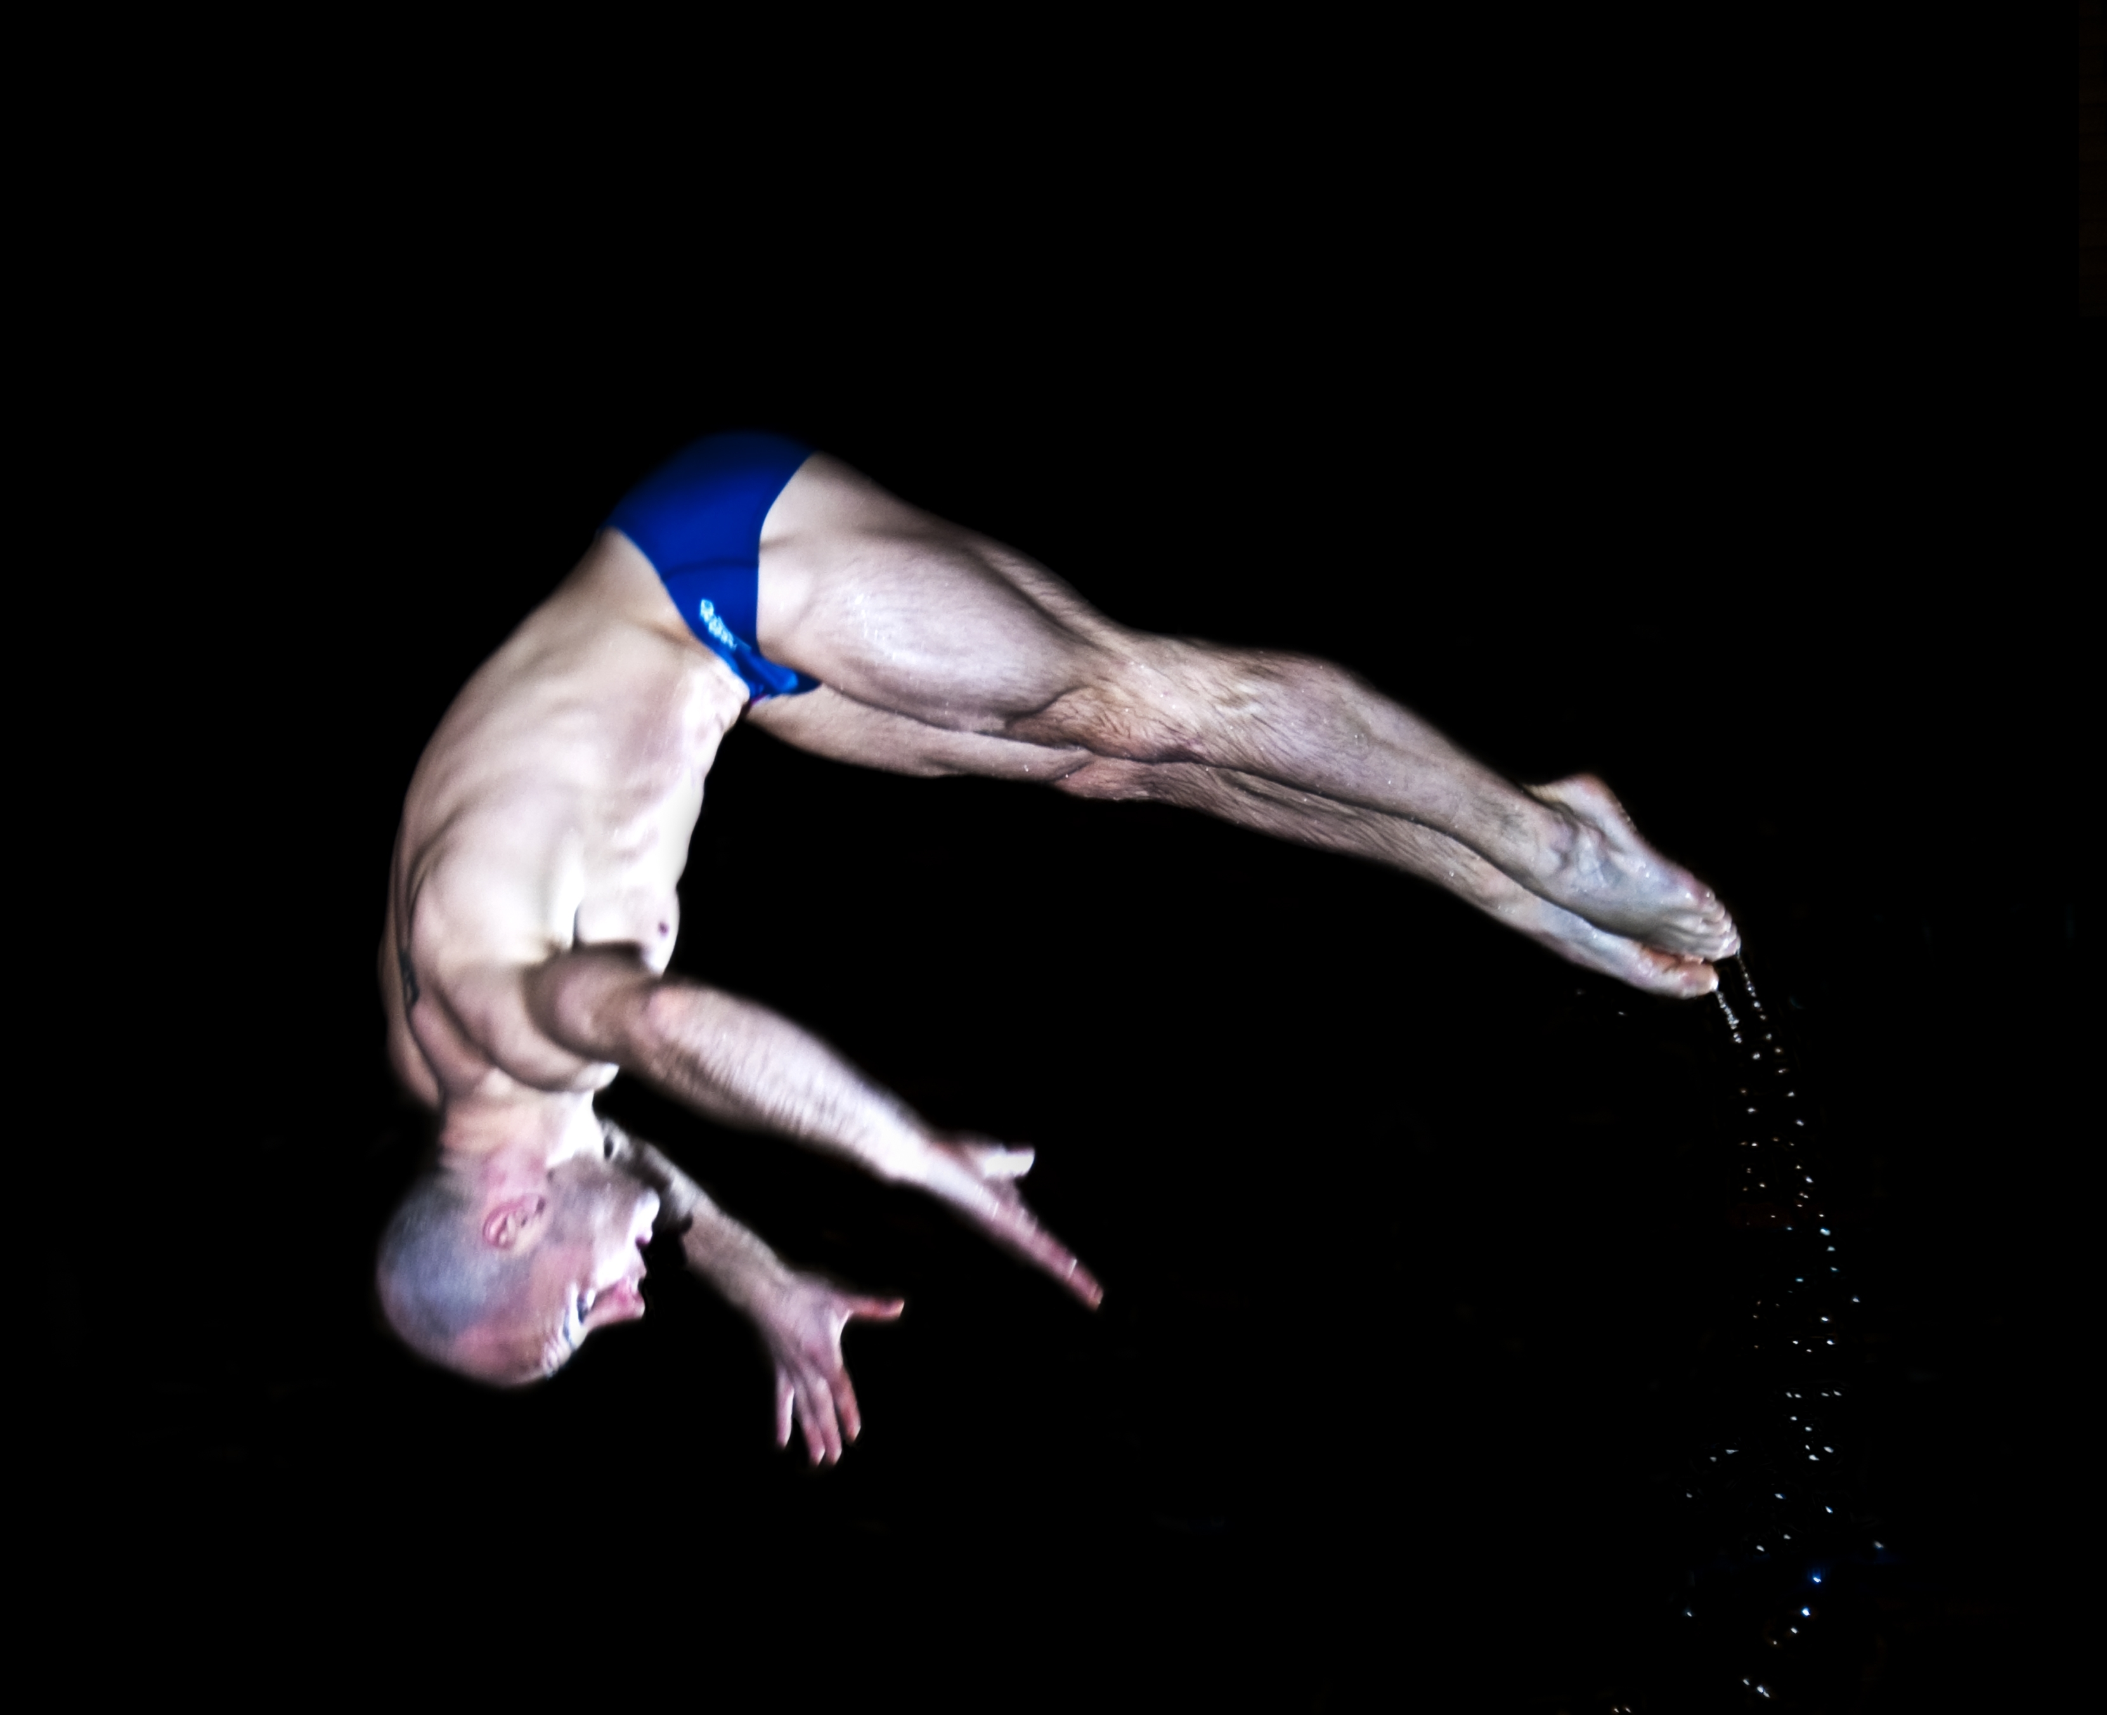
APPLICATION FORM FOR FAMILY DIVING LESSON

Name 1:…………………………………… Name 2:……………………………………….

Name 3:…………………………………… Name 4:……………………………………….

Address of main applicant:………………………………………………………………………….

…………………………………………………………….. Postcode:……………………………...

Tel:……………………………. Email:…………………………………………………

Please ensure you provide an email address as your confirmation of place will be sent by email

Date of birth 1:……………… DOB 2:………………… DOB 3:………………… DOB 4:…………....

Emergency tel no during session:………………………………

Medical information: Do you/your child have any medical condition that the coach should be aware of (eg asthma, allergies, epilepsy)? Please give details.

Applicant 1:

Applicant 2:

Applicant 3:

Applicant 4:

Are you/your child taking any medication? Please give details.

Applicant 1:

Applicant 2:

Applicant 3:

Applicant 4:

Is there any other relevant information (eg learning difficulties, behaviour etc) that it would be useful for the coach to know? Please give details.

Applicant 1:

Applicant 2:

Applicant 3:

Applicant 4:

I confirm that all applicants can swim at least 25m on their front unaided, are confident in deep water and happy to swim without goggles.

Signed:……………………………………………………(Participant/Parent) Date:…………………

PLEASE FILL IN ALL SECTIONS OF THIS FORM AND LET US KNOW IF ANY OF THIS INFORMATION CHANGES BEFORE THE SESSION. THANK YOU.

Return to: Annie Clewlow, The Quays Swimming and Diving Complex, 27, Harbour Parade, Southampton, SO15 IBA.
Tel: 023 8072 0922 Email: divingatthequays@activenation.org.uk

Please tick times required:
OLYMPIC MASTERCLASSES: FAMILY (30 min)
Day | Date | Time |  |  | Day | Date | Time
Mon | 08/08/16 | 18:15 |  |  | Wed | 19/08/16 | 18:15

Method of payment (please tick)

£20/session for 2 participants
£28/session for 3 participants
£36/session for 4 participants

Cash ___ (Please pay at reception) Cheque ___ (Please make payable to Active Nation UK Ltd)

Credit/Debit Card ___ (Please pay at reception/fill in details below and hand in at reception)

Charge my Visa/Mastercard/Switch/Delta*

Expiry date:…………

3 digit security no:………………. *Switchcard Version/Issue no:…………….
(Final 3 numbers on signature strip on reverse of card)

PLEASE ENSURE THAT BOOKINGS ARE MADE AT LEAST 48H BEFORE THE SESSION
Payment must be made at the time of booking

